Consumer GUID – 23c276c6-5262-4b9d-914d-1f0a52e0df86

First Ginger Dispute Reference ID 10745049



Address Link ID = 81285354



@LinkResId @ResId

219264230 219264229

7 6

No results from [up_AddressLink_GatherResidenceDataAssets]

switched

DataAssetId DataAssetType

81285353 AdditionalAddressLink

81285359 AdditionalAddressLink

Outcome is would auto delete

Second Ginger Dispute Reference ID 10745050

Address Link ID = 81285353 - Would go to manual processing

@LinkResId @ResId

219264229 219264228

6 5

DataAssetId DataAssetType

81285354 AdditionalAddressLink

81285360 AdditionalAddressLink

Switched

DataAssetId DataAssetType

81285352 AdditionalAddressLink

81285358 AdditionalAddressLink

Outcome is would go to manual processing

Further Tests against all dispute links in Ginger Credit Report view for consumer 23c276c6-5262-4b9d-914d-1f0a52e0df86

Note that this illustrates that the same address link ID is send to Numero for either address that is disputed in a particular address link. This would result in an auto removal of address if 6 or 7 Prescott street is disputed in the bottom address link.

Test 1 against third address link – 6 Prescott Street



Ginger Dispute reference number – 10745049 – Raised Sep 11, 2019 10:43:35

Numero Dispute Case ID – 5539

Numero Outcome - Address Link Removed (Auto)

Address Link ID – 81285354

Test 2 against second address link – 6 Prescott Street



Ginger Dispute reference number – 10745050 – Raised Sep 11, 2019 10:45:05

Numero Dispute Case ID – 5540

Numero Outcome – Manual Processing

Address Link ID - 81285353

Test 3 against first address link – 5 Prescott Street



Ginger Dispute reference number – 10753680 – Raised Sep 11, 2019 13:38:05

Numero Dispute Case ID – **5541**

Numero Outcome – Manual Processing

Address Link ID - 81285352

Test 4 against first address link – 4 Prescott Street



Ginger Dispute reference number – 10753681 – Raised Sep 11, 2019 13:38:50

Numero Dispute Case ID – **5541**

Numero Outcome – Manual Processing

Address Link ID - 81285352

Test 5 against second address link – 5 Prescott Street



Ginger Dispute reference number – 10753683 – Raised Sep 11, 2019 13:47:01

Numero Dispute Case ID – 5543

Numero Outcome – Rejected (Auto)

Address Link ID - 81285353

Test 6 against third address link – 7 Prescott Street



Ginger Dispute reference number – 10753682 – Raised Sep 11, 2019 13:39:34

Numero Dispute Case ID – 5542

Numero Outcome - Address Link Removed (Auto)

Address Link ID - 81285354

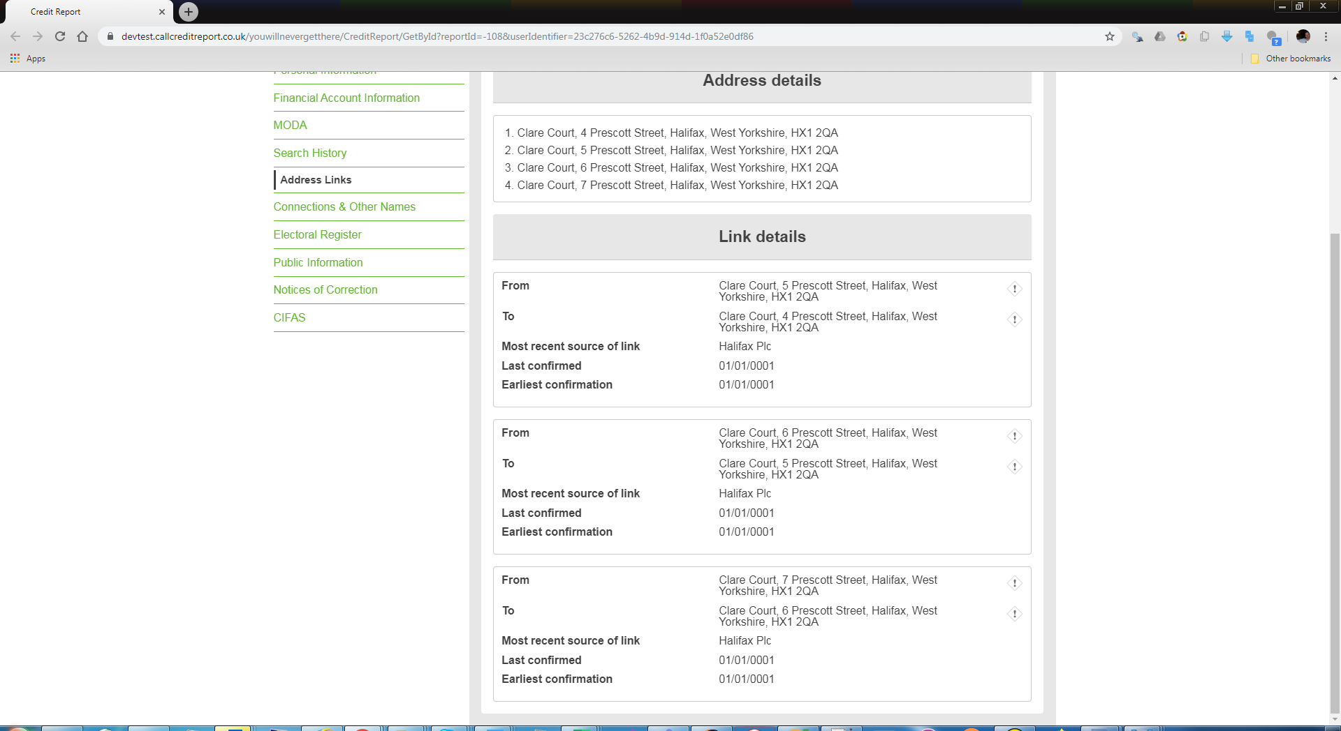



Ginger Administration Panel showing Dispute for Test 1

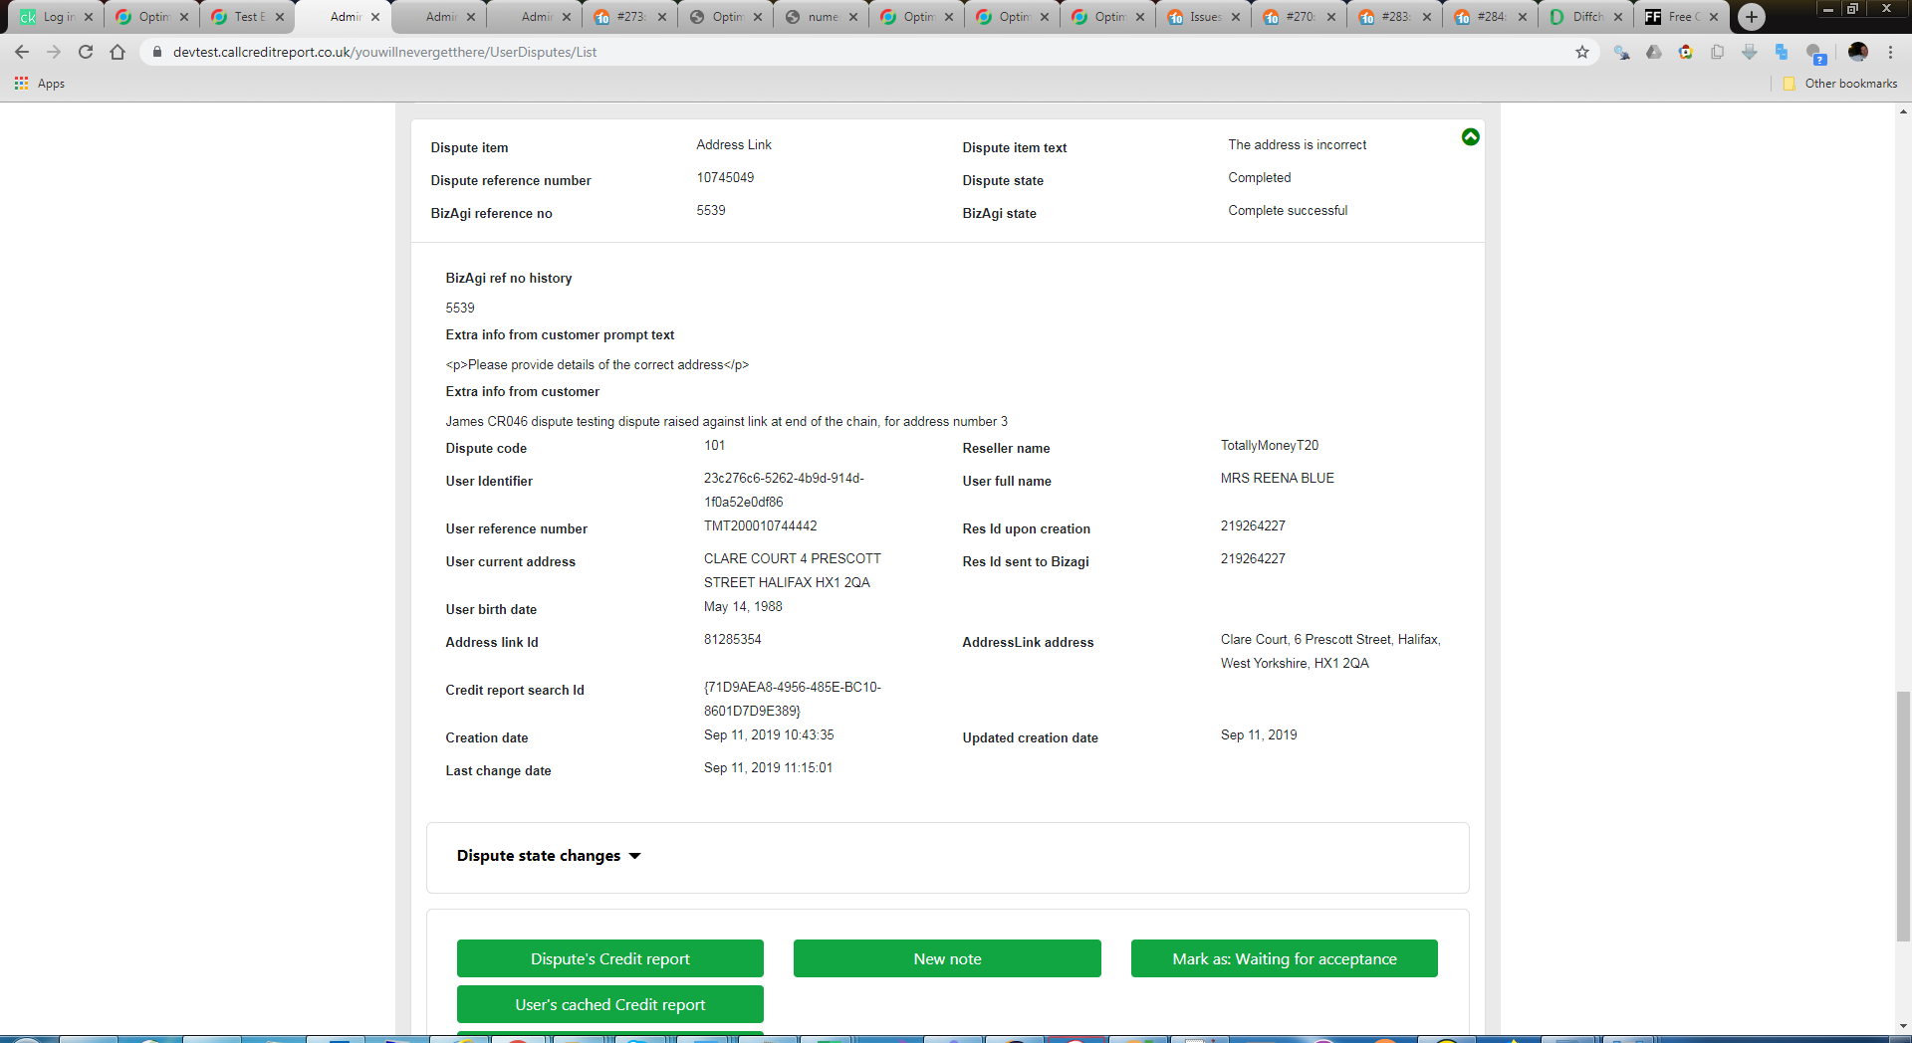

XML sent to Numero for Test 1

<?xml version="1.0" encoding="UTF-8"?>

<s:Envelope xmlns:s="http://www.w3.org/2003/05/soap-envelope">

<s:Body xmlns:xsd="http://www.w3.org/2001/XMLSchema" xmlns:xsi="http://www.w3.org/2001/XMLSchema-instance">

<createCases xmlns="http://tempuri.org/">

<casesInfo>

<BizAgiWSParam xmlns="">

<domain>domain</domain>

<userName>admon</userName>

<Cases>

<Case>

<Process>Disputes</Process>

<Entities>

<CallCredit>

<Dispute>

<IsAutomatic>1</IsAutomatic>

<DateReceived>2019-09-11</DateReceived>

<DisputeId>10745049</DisputeId>

<CCCDisputeType>101</CCCDisputeType>

<CCCAffiliateID>539</CCCAffiliateID>

<ConsumerRequest>Dispute Text: James CR046 dispute testing dispute raised against link at end of the chain, for address number 3 Address link address: Clare Court, 6 Prescott Street, Halifax, West Yorkshire, HX1 2QA Dispute detail data: Selected Address: Clare Court, 6 Prescott Street, Halifax, West Yorkshire, HX1 2QA Address 1: CLARE COURT, 7 PRESCOTT STREET, HALIFAX, WEST YORKSHIRE, HX1 2QA Address 2: CLARE COURT, 6 PRESCOTT STREET, HALIFAX, WEST YORKSHIRE, HX1 2QA ADD Link ID:81285354 Link Creation Date: 01/01/0001 00:00:00 Link Last Conf Date: 01/01/0001 00:00:00 Link Supplier Name: Halifax plc</ConsumerRequest>

<CCCCustomerID>10744442</CCCCustomerID>

<ResidenceID>219264227</ResidenceID>

<Name>

<TitleOther>MRS</TitleOther>

<Forename>REENA</Forename>

<MiddleName />

<Surname>BLUE</Surname>

</Name>

<DoB>1988-05-14</DoB>

<UKAddress>

<Abode />

<HouseName>CLARE COURT</HouseName>

<HouseNumber>4</HouseNumber>

<Street1>PRESCOTT STREET</Street1>

<Street2 />

<Town>HALIFAX</Town>

<PostCode>HX1 2QA</PostCode>

</UKAddress>

<CCCAddressLinkID>81285354</CCCAddressLinkID>

<UserID>23c276c6-5262-4b9d-914d-1f0a52e0df86</UserID>

<UserEmail>TUVeryLow@mail.com</UserEmail>

</Dispute>

</CallCredit>

</Entities>

</Case>

</Cases>

</BizAgiWSParam>

</casesInfo>

</createCases>

</s:Body>

</s:Envelope>

Below shows how the data was setup in the DB, illustrates the data origin and direct/implied address link configuration;

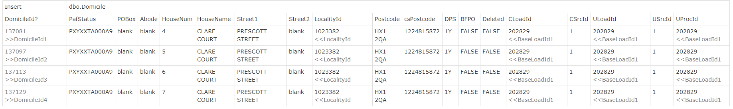

Note ResidenceId1 = DomicileId1, ResidenceId2 = DomicileId2 etc

